12-1: INSERT Statements

**Vocabulary**

Someone doing “real work” with the computer, using it as a means rather than an end - User

Consists of a collection of DML statements that form a logical unit of work. - transaction

Fully and clearly expressed; leaving nothing implied - explicit

Adds a new row to a table – INSERT INTO

**Try it / Solve it**

1. Give two examples of why it is important to be able to alter the data in a database.

- например, сайт ВКонтакте, на котором каждый день регистрируются новые пользователи, если изменять базу данных пользователей будет нельзя, то новые пользователи добавлены не будут и войти на сайт новым пользователем будет невозможно, кроме того существующие пользователи не смогут менять пароль, не смогут обновлять фотографии профиля, не будут сохраняться и отправляться новые сообщения, то есть сайт фактически умрет.

- люди каждый день совершают новые преступления, поэтому база данных МВД ежедневно обновляется, а если нельзя будет добавлять новых пользователей и изменять судимость существующих, то будут БООООЛЬШИЕ проблемы

2. DJs on Demand just purchased four new CDs. Use an explicit INSERT statement to add each CD to the copy_d_cds table. After completing the entries, execute a SELECT * statement to verify your work.

CD_Number Title Producer Year

97 Celebrate the Day R & B Inc. 2003

98 Holiday Tunes for All Ages Tunes are Us 2004

99 Party Music Old Town Records 2004

1. st of Rock and Roll Old Town Records 2004

1. DJs on Demand has two new events coming up. One event is a fall football party and the other event is a sixties theme party. The DJs on Demand clients requested the songs shown in the table for their events. Add these songs to the copy_d_songs table using an implicit INSERT statement.

4. Add the two new clients to the copy_d_clients table. Use either an implicit or an explicit INSERT.

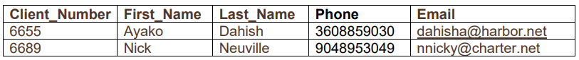

5.Add the new client’s events to the copy_d_events table. The cost of each event has not been determined at this date.

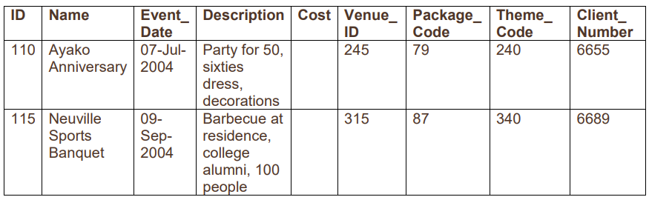6. Create a table called rep_email using the following statement: CREATE TABLE rep_email ( id NUMBER(3) CONSTRAINT rel_id_pk PRIMARY KEY, first_name VARCHAR2(10), last_name VARCHAR2(10), email_address VARCHAR2(10)) A screenshot of a computer
